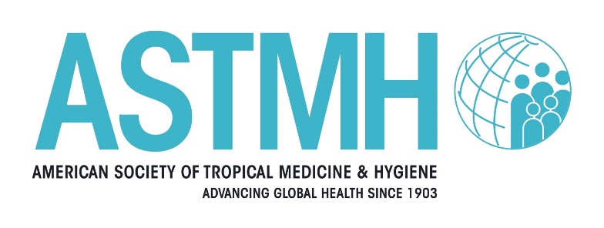

Update Course in Clinical Tropical Medicine & Travelers’ Health
2026 Hybrid
August 16, 2026 In-Person and Livestream
Ulysses Guimarães Convention Center - Brasilia, Brasil
September 19, 2026 Virtual Online Only

Sunday, August 16, 2026 |  | Saturday, September 19, 2026
IN-PERSON/LIVESTREAM (BRT) |  | Virtual Only (EST)
8 a.m. – 8:30 a.m. | Chairs: Welcome and Introduction: Intro to Kaizen and Review of Questions  Aisha Khatib, MD, CCFP(EM), CTravMed, DTM&H, FISTM*  CTropMed® Diplomate  University of Toronto  Toronto, Ontario, Canada  German Henostroza, MD*  Professor, Infectious Diseases  University of Alabama at Birmingham  Birmingham, Alabama, United States | 8:15 a.m. – 8:30 a.m. | Chairs Welcome  Aisha Khatib, MD, CCFP(EM), CTravMed, DTM&H, FISTM*  CTropMed® Diplomate  University of Toronto  Toronto, Ontario, Canada  German Henostroza, MD*  Professor, Infectious Diseases  University of Alabama at Birmingham  Birmingham, Alabama, United States
8:30 a.m. – 9:30 a.m. | Diagnosing Brazil: Clinical Cases from a Tropical Medicine Hotspot  Kleber Giovanni Luz, MD, PhD  Prof. Associate IV - Department of Infectious Diseases/ Institute of Tropical Medicine of Rio Grande do Norte/ UFRN/ Hospital Giselda Trigueiro, Brazil | 8:30 a.m. – 9:30 a.m. | Nipah Virus: A High-Consequence Emerging Pathogen  Anish T. S., DPH, MD, MPhil  Professor and Nodal Officer  Kerala One Health Centre for Nipah Research and Resilience  Kerala, India
9:30 a.m. - 10:15 a.m. | Yellow Fever  Rodrigo Schrage Lins, MD, MSc, PhD  Professor, Infectious Diseases  IDOMED Angra dos Reis  Scientific Committee on Immunizations – SBI  Rio de Janeiro, Brazil | 9:30 a.m. – 10:15a.m. | Ebola  Edwin Nuwagira, Mmed  Department of Internal Medicine  Special Pathogens Department  Mbarara University of Science & Technology  Mbarara, Uganda
10:15 a.m. – 10:30 a.m. | Break | 10:15 a.m. – 10:30 a.m. | Break
10:30 a.m. – 11:15 a.m. | Dengue & the Path to Treatment  Andre Siqueira  Head of Dengue Global Programme at DNDi Médico  Tropicalista e Pesquisador em Saúde Pública no INI/FIOCRUZ  Rio de Janeiro, Brazil | 10:30 a.m. – 11:15 a.m. | Use of AI in Tropical Medicine  Nick Tarazona, MD  Pontifical Xavierian University  Director de Inteligencia Artificial  Fundación para la Innovación en Salud  Medellín, Colombia
11:15 a.m. - 12:15 p.m. | Emerging Mycoses: Cases from Peru  Carlos Seas, MD, FIDSA  Profesor Asociado  Departamento de Clínicas Médicas  Facultad de Medicina Alberto Hurtado  Universidad Peruana Cayetano Heredia, Lima, Peru | 11:15 a.m. – 12:15 p.m. | Arboviruses on the Move: Outbreaks, Vaccines, and Emerging Risks  TBD
12:15 p.m. – 1:15 p.m. | Lunch Break | 12:15 p.m. – 1 p.m. | Lunch
1:15 p.m. – 2:15p.m. | Clinical Parasitology Cases from Brazil  Karis Maria De Pinho Rodrigues, MD, PhD  Titular Professor of Infectious Diseases - Universidade Estácio de Sá/IDOMED; Associate Professor of Infectious Diseases - Universidade Federal do Rio de Janeiro, Brazil | 1 p.m. – 1:45 p.m. | Challenging Cases in Tuberculosis  German Henostroza, MD  Professor, Infectious Diseases  University of Alabama at Birmingham  Birmingham, Alabama, United States
2:15 p.m. – 3:15 p.m. | Case Challenge Panel: What's Your Diagnosis?  Panel:  Kleber Giovanni Luz, MD, PhD  Karis Maria De Pinho Rodrigues, PhD  Carlos Seas, MD, FIDSA | 1:45 p.m. – 2:45 p.m. | Viral Haemorrhagic Fevers  Mark Kortepeter, MD, MPH, FASTMH  Uniformed Services University of the Health Sciences  Potomac, Maryland, United States
3:15 p.m. – 3:45 p.m. | Break | 2:45 p.m. – 3 p.m. | Break
3:45 p.m. – 4:30 p.m. | Clinical Lessons from Outbreaks in Brazil  Lessandra Michelin MD, MSc, PhD  Professor of Infectious Diseases & Pediatrics, Universidade de Caxias do Sul, Brazil | 3 p.m. – 3:45 p.m. | Mass Gatherings  Salim Parker, MD  Hajj and Travel Medicine  Global Centre for Mass Gathering Medicine  University of Cape Town  Cape Town, South Africa
4:30 p.m. – 5 p.m. | Wrap-up | 3:45 p.m. – 4:30 p.m. | Climate and Disease: The Clinical Impact of Super El Niño  Jan Semenza, PhD  Environmental Epidemiologist  Head of Health Determinants Programme  European Center for Disease Prevention and Control  Department of Sustainable Health at Umeå University in Sweden and Heidelberg Institute of Global Health, at the University of Heidelberg in Germany.
 |  | 4:30 p.m. – 5 p.m. | Kaizen & Course Wrap-up

*ASTMH Member

