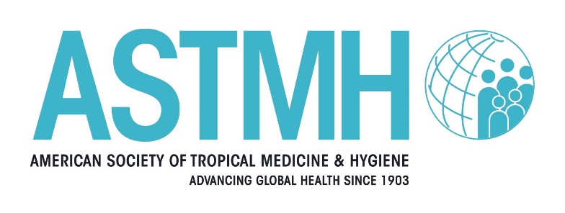

Update Course in Clinical Tropical Medicine & Travelers’ Health
2026 Hybrid
August 16, 2026 In-Person and Livestream
Ulysses Guimarães Convention Center - Brasilia, Brasil
September 19, 2026 Virtual Online Only

Sunday, August 16, 2026 |  | Saturday, September 19, 2026
IN-PERSON/LIVESTREAM (BRT) |  | Virtual Only (EST)
8 a.m. – 8:30 a.m. | Chairs: Welcome and Introduction: Intro to Kaizen and Review of Questions  Aisha Khatib, MD, CCFP(EM), CTravMed, DTM&H, FISTM*  CTropMed® Diplomate  University of Toronto  Toronto, Ontario, Canada  German Henostroza, MD*  Professor, Infectious Diseases  University of Alabama at Birmingham  Birmingham, Alabama, United States | 8:15 a.m. – 8:30 a.m. | Chairs Welcome  Aisha Khatib, MD, CCFP(EM), CTravMed, DTM&H, FISTM*  CTropMed® Diplomate  University of Toronto  Toronto, Ontario, Canada  German Henostroza, MD*  Professor, Infectious Diseases  University of Alabama at Birmingham  Birmingham, Alabama, United States
8:30 a.m. – 9:30 a.m. | Diagnosing Brazil: Clinical Cases from a Tropical Medicine Hotspot  Kleber Giovanni Luz, MD, PhD  Prof. Associate IV - Department of Infectious Diseases/ Institute of Tropical Medicine of Rio Grande do Norte/ UFRN/ Hospital Giselda Trigueiro, Brazil | 8:30 a.m. – 9:30 a.m. | Ebola
9:30 a.m. - 10:15 a.m. | Hantavirus  Alejandro Lepetic, MD  Professor, School of Medicine, National University of Buenos Aires  Founding Member of SLAMVI, Argentina | 9:30 a.m. – 10:15a.m. | Nipah Virus: A High-Consequence Emerging Pathogen
10:15 a.m. – 10:30 a.m. | Break | 10:15 a.m. – 10:30 a.m. | Break
10:30 a.m. – 11:15 a.m. | Clinical Lessons from Outbreaks in Brazil  Lessandra Michelin MD, MSc, PhD  Professor of Infectious Diseases & Pediatrics, Universidade de Caxias do Sul, Brazil | 10:30 a.m. – 11:15 a.m. | Use of AI in Tropical Medicine
11:15 a.m. - 12:15 p.m. | Emerging Mycoses: Cases from Peru  Carlos Seas, MD, FIDSA  Profesor Asociado  Departamento de Clínicas Médicas  Facultad de Medicina Alberto Hurtado  Universidad Peruana Cayetano Heredia, Lima, Peru | 11:15 a.m. – 12:15 p.m. | Arboviruses on the Move: Outbreaks, Vaccines, and Emerging Risks
12:15 p.m. – 1:15 p.m. | Lunch Break | 12:15 p.m. – 1 p.m. | Lunch
1:15 p.m. – 2:15p.m. | Clinical Parasitology Cases from Brazil  Karis Maria De Pinho Rodrigues, MD, PhD  Titular Professor of Infectious Diseases - Universidade Estácio de Sá/IDOMED; Associate Professor of Infectious Diseases - Universidade Federal do Rio de Janeiro, Brazil | 1 p.m. – 1:45 p.m. | Outbreak Response in Resource Limited Settings
2:15 p.m. – 3:15 p.m. | Sexually Transmitted Infections on the Rise  Alejandro Lepetic, MD | 1:45 p.m. – 2:45 p.m. | Climate, Vectors, and Disease: The Clinical Impact of Super El Niño
3:15 p.m. – 3:30p.m. | Break | 2:45 p.m. – 3 p.m. | Break
3:30 p.m. – 4:30 p.m. | Case Challenge Panel: What's Your Diagnosis?  Panel:  Kleber Giovanni Luz, MD, PhD  Karis Maria De Pinho Rodrigues, PhD  Carlos Seas, MD, FIDSA | 3 p.m. – 3:45 p.m. | Updates in Tuberculosis  German Henostroza, MD
4:30 p.m. – 5 p.m. | Wrap-up | 3:45 p.m. – 4:30 p.m. | Mass Gatherings
 |  | 4:30 p.m. – 5 p.m. | Kaizen & Course Wrap-up

*ASTMH Member

